Deliverable D03-D04: Performance Report

-

Group E8.02

## 

Github Repository: <https://github.com/JStockwell/Acme-One-E8.02>

Members:

* Gregorio Ortega Soldado ([greortsol@alum.us.es](mailto:greortsol@alum.us.es))
* Alejandro Manuel Gestoso Torres ([alegestor@alum.us.es](mailto:alegestor@alum.us.es))
* Jaime Stockwell Mendoza ([jaistomen@alum.us.es](mailto:jaistomen@alum.us.es))
* Pablo Aurelio Sánchez Valenzuela ([pabsanval1@alum.us.es](mailto:pabsanval1@alum.us.es))
* Manuel Cabra Morón ([mancabmor1@alum.us.es](mailto:mancabmor1@alum.us.es))
* Fernando Claros ([ferclabar@alum.us.es](mailto:ferclabar@alum.us.es))

## Fecha: 01/03/2022

# Table of Contents

| 1. Executive Summary 2. Revision Table 3. Introduction 4. Contents 5. Conclusions | 2  2  3  3  5 |
| --- | --- |

# 

# Executive Summary

We are a group of 6 java developers, one of us is also the project manager of the team. We all are studying 3rd year in a software engineering degree and we have experience in projects due to other subjects like AISS, DP1, PSG1, IISSI1 and IISSI2.

Our product is a web information system which uses java technology, an IDE like Eclipse and 2 programs to interact with databases like MariaDB and DBeaver.

Our procedure is using github to establish a common cloud and a control version using branches that will commit to the main code and kanban boards to organize the work. We also use Scrum methodology to organize ourselves as a team.

# Revision Table

| Revision | Description | Date |
| --- | --- | --- |
| v1.0 | Initial Creation | 17/04/2022 |
| v1.1 | D03 Report | 25/04/2022 |

# 

# Introduction

In this document we will analyse the performance of our project, comparing between two different computers.

# Content

D03 Report

Here we have the graph corresponding to the first PC’s performance showing the performance of the project. As we can see the feature with that takes the most to respond is /any/announcement/list nearing 1.5 seconds in respond time

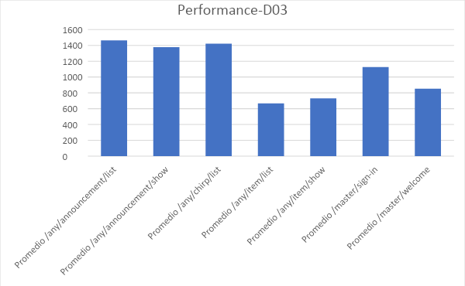

**PC 1 Performance**

| *time* | |  |
| --- | --- | --- |
|  |  |  |
| Mean | 913,48159 |  |
| Standard Error | 52,8377217 |  |
| Median | 568 |  |
| Mode | 565 |  |
| Standard Deviation | 1327,26842 |  |
| Sample Variance | 1761641,47 |  |
| Kurtosis | 27,9601127 |  |
| Skewness | 4,92329575 |  |
| Range | 9949 |  |
| Minimum | 216 |  |
| Maximum | 10165 |  |
| Sum | 576406,884 |  |
| Count | 631 |  |
| Confidence Level (95,0%) | 103,759369 |  |
|  |  |  |
| Confidence interval | 809,722222 | 1017,24096 |
| **PC 2 performance** |  |  |
| | *time* | |  | | --- | --- | --- | |  |  |  | | Mean | 560,4286 |  | | Standard Error | 36,58977 |  | | Median | 554 |  | | Mode | 554 |  | | Standard Deviation | 454,0671 |  | | Sample Variance | 206176,9 |  | | Kurtosis | 76,50039 |  | | Skewness | 7,955534 |  | | Range | 4965 |  | | Minimum | 265 |  | | Maximum | 5230 |  | | Sum | 86306 |  | | Count | 154 |  | | Confidence Level (95,0%) | 72,28639 |  | |  |  |  | | Confidence Interval | 488,1422 | 632,715 | |  |  |
|  |  |  |

As we can see, the performance from the second PC is better than that of the first one both having a difference of almost 400 on both limits of the interval. However, the minimum on the first PC has been better than that of the second one but overall the second PC performs better than the first one as the mean is smaller, as well as the deviation, which means that the values of the performance are more representative than those of the first PC with a deviation that double that of the second one.

D04 Report

Here we have the graph showing us the performance of the project of the first PC, as we can see the /any/chirp/list is the one taking the most time to respond getting near the 1 second mark but without surpassing it

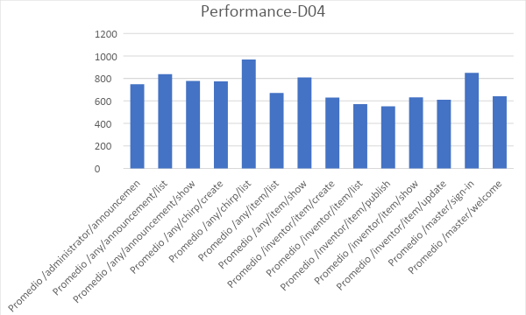

**PC1 Performance**

| *time* | |  |
| --- | --- | --- |
|  |  |  |
| Mean | 691,5269 |  |
| Standard Error | 20,12259 |  |
| Median | 558 |  |
| Mode | 557 |  |
| Standard Deviation | 1048,694 |  |
| Sample Variance | 1099759 |  |
| Kurtosis | 82,35057 |  |
| Skewness | 8,318622 |  |
| Range | 12478 |  |
| Minimum | 134 |  |
| Maximum | 12612 |  |
| Sum | 1878187 |  |
| Count | 2716 |  |
| Confidence Level (95,0%) | 39,45715 |  |
|  |  |  |
| Confidence Interval | 652,0698 | 730,9841 |

**PC2 Performance**

| *time* | |  |
| --- | --- | --- |
|  |  |  |
| Mean | 492,3075 |  |
| Standard Error | 6,854368 |  |
| Median | 553 |  |
| Mode | 555 |  |
| Standard Deviation | 207,1108 |  |
| Sample Variance | 42894,89 |  |
| Kurtosis | 126,9727 |  |
| Skewness | 7,752527 |  |
| Range | 4004 |  |
| Minimum | 267 |  |
| Maximum | 4271 |  |
| Sum | 449476,8 |  |
| Count | 913 |  |
| Confidence Level (95,0%) | 13,45217 |  |
|  |  |  |
| Confidence Interval | 478,8554 | 505,7597 |

This time the confidence interval of the first PC is within the expected performance of less than 1 second. The difference between the performances of both PCs is of 200 ms in both the upper and lower limit. However, this first PC has a lower minimum in comparison to the second PC. However, in overall the second PC is better than the first one as the limits of the confidence interval are lower as well as the overall mean and the standard deviation of the values corresponding to the second PC